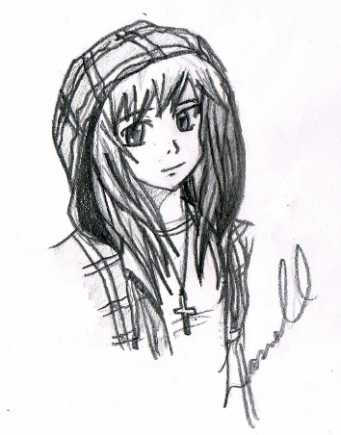
ROCKY TOP OFF THE WALL ART AND MANGA CLUB
Club Description:

ROCKY TOP ART CLUB will offer a variety of art related activities to students through an after school program

Art Club is a safe, inviting place where all students who are interested in art can come together and hang out. Students will be able to interact with other students with interests in art, be able to work on different art projects, and participate in community service activities.

The Goal For Art Club Is To:

*Teach members about the creation process
*Help members plan and create their own projects
*Get members involved in community and school wide art work
*Encourage members to explore new creative ideas

When is Art Club?

Art Club will meet most Thursday’s after school from
4:00pm – 5:15 (clean up at 5:00). First club date is October 4th.

The Art Club dates may also be accessed from the Rocky Top website.

Dates of Art Club Meetings:

Thursday, October 4th
Thursday, October 18th
Thursday, October 25th

Thursday, November 1st
Thursday, November 8th
Thursday, November 15th
Thursday, November 29th

Thursday, December 6th
Thursday, December 13th
Thursday, December 20th

Thursday, January 10th
Thursday, January 17th
Thursday, January 24th
Thursday, January 31st

Thursday, February 7th
Thursday, February 21st
Thursday, February 28th

Thursday, March 7th
Thursday, March 14th
Thursday, March 21st

Thursday, April 4th
Thursday, April 11th
Thursday, April 18th
Thursday, April 25th

Thursday, May 9th (Pizza Party)

Rocky Top Middle School Off the Wall Art Club
Permission Form

Please return completed form to Ms. Stutzman on the first day of Art Club.

My student _________________________________________ has my permission to stay after school on designated dates from 4:00-5:15 for Art Club.

___________________________________________________
Parent/Guardian Signature

Please note that all Adams 12 Five Star School District rules, policies and student expectations will be adhered to. If at any time a club sponsor denotes inappropriate behavior or behavior that could be deemed unsafe, the student relinquishes their opportunity to participate in Art Club.

